- Test Dataset: 10100AA158004
S‐158 Recommended ENC Validation Checks covered in this section:
S‐158 Check | Description
101_1183 | For each Dam which is not COVERED_BY a LandArea of geometric primitive surface.
101_1040 | For each LandArea geometry primitive surface where scaleMinimum is Present.
101_1279 | For each NavigationLine where orientationValue is Known AND the bearing of the line is more than 5 degrees Greater than OR Less than the value (or reciprocal value) of orientationValue.
101_1289 | For each RangeSystemAggregation with a single instance of both NavigationLine and RecommendedTrack AND the orientationValue of the RecommendedTrack is more than 3 degrees Greater than OR Less than the value (or reciprocal value) of the orientationValue of the NavigationLine feature.
101_1286 | For each RecommendedTrack where orientationValue is Known AND trafficFlow is Equal to 1 (inbound) OR 2 (Outbound) OR 3 (One-Way) AND the bearing of the line is more than 3 degrees Greater than OR Less than the value of orientationValue.
101_1205 | For each SweptArea which is not COVERED_BY the combined coverage of DepthArea and DredgedArea features.

Secondary Errors
Critical – None
Error – 2
Warnings – 1
Dataset Name | 10100AA158004 |  | S‐158 Check |  | 101_1183 |  |  | Type |  | C
S-158 Description | For each Dam which is not COVERED_BY a LandArea of geometric primitive surface.
Message | Dam is not covered by a LandArea feature
Solution | Ensure Dam feature is covered by a LandArea feature. |  |  |  | Conformity |  | PS 8.12.1
Test Case No. 1 | Dam is not covered by a LandArea feature
Location | Feature | Attributes |  | FRID |  | FOID |  |  | VRID
32.381925S, 61.751692E | Dam |  |  | 14 |  | 1810:6783:1 |  |  | -
Screen Capture | 
Expected Test Results | 101_1183: An error “Dam is not covered by a LandArea feature” must be triggered.
Secondary Critical Errors | None

Dataset Name | 10100AA158004 |  | S‐158 Check |  | 101_1040 |  |  | Type |  | C
S-158 Description | For each LandArea geometry primitive surface where scaleMinimum is Present.
Message | LandArea of geometric primitive surface has value of scaleMinimum.
Solution | Remove the scaleMinimum attribute value. |  |  |  | Conformity |  | PS 8.12.1
Test Case No. 1 | LandArea of geometric primitive surface has value of scaleMinimum.
Location | Feature | Attributes |  | FRID |  | FOID |  |  | VRID
32.338097S, 61.756743E | LandArea |  |  | 16 |  | 1810:6785:1 |  |  | -
Screen Capture | 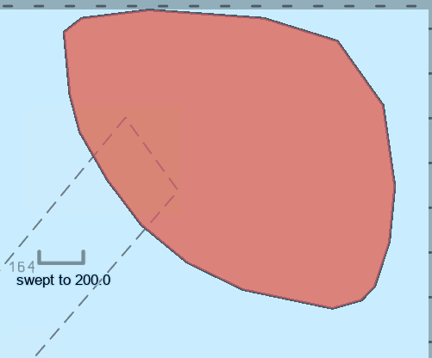
Expected Test Results | 101_1040: An error “LandArea of geometric primitive surface has value of scaleMinimum.” must be triggered.
Secondary Critical Errors | None

Dataset Name | 10100AA158004 |  | S‐158 Check |  | 101_1279 |  |  | Type |  | C
S-158 Description | For each NavigationLine where orientationValue is Known AND the bearing of the line is more than 5 degrees Greater than OR Less than the value (or reciprocal value) of orientationValue.
Message | orientationValue for NavigationLine does not correspond to the bearing of the line.
Solution | Amend orientationValue to be consistent with orientation of the curve spatial feature it references. |  |  |  | Conformity |  | PS 15.4.1
Test Case No. 1 | orientationValue for NavigationLine does not correspond to the bearing of the line.
Location | Feature | Attributes |  | FRID |  | FOID |  |  | VRID
32.401869S, 61.755077E | NavigationLine | categoryOfNavigationLine 1  orientation/orientationValue 95 |  | 39 |  | 1810:8354:1 |  |  | -
Screen Capture | 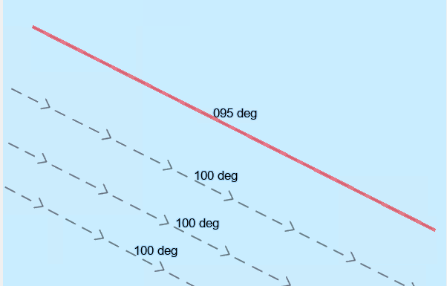
Expected Test Results | 101_1279: An error “orientationValue for NavigationLine does not correspond to the bearing of the line.” must be triggered.
Secondary Critical Errors | None

Dataset Name | 10100AA158004 |  | S‐158 Check |  | 101_1289 |  |  | Type |  | C
S-158 Description | For each RangeSystemAggregation with a single instance of both NavigationLine and RecommendedTrack AND the orientationValue of the RecommendedTrack is more than 3 degrees Greater than OR Less than the value (or reciprocal value) of the orientationValue of the NavigationLine feature.
Message | orientationValue of RangeSystem components RecommendTrack and NavigationLine features are inconsistent.
Solution | Amend orientationValue to be consistent with orientation of the curve spatial feature it references. |  |  |  | Conformity |  | PS 15.6.1
Test Case No. 1 | orientationValue of RangeSystem components RecommendTrack and NavigationLine features are inconsistent.
Location | Feature | Attributes |  | FRID |  | FOID |  |  | VRID
32.410043S, 61.756665E | RangeSystem |  |  | 41 |  | 1810:6842:1 |  |  | -
 | NavigationLine |  |  | 8 |  | 1810:6775:1
 | RecommendedTrack |  |  | 13 |  | 1810:6782:1
Screen Capture | 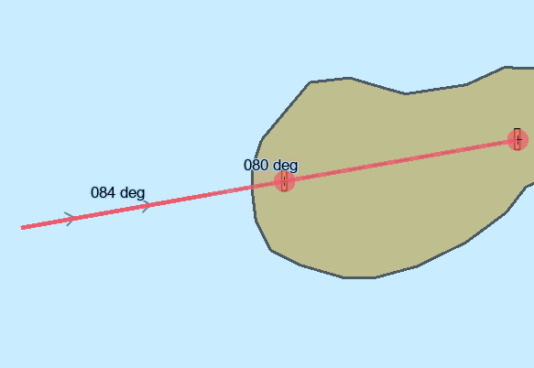
Expected Test Results | 101_1289: An error “orientationValue of RangeSystem components RecommendTrack and NavigationLine features are inconsistent.” must be triggered.
Secondary Critical Errors | 2

Dataset Name | 10100AA158004 |  | S‐158 Check |  | 101_1286 |  |  | Type |  | C
S-158 Description | For each RecommendedTrack where orientationValue is Known AND trafficFlow is Equal to 1 (inbound) OR 2 (Outbound) OR 3 (One-Way) AND the bearing of the line is more than 3 degrees Greater than OR Less than the value of orientationValue.
Message | orientationValue for RecommendedTrack does not correspond to the bearing of the line.
Solution | Amend orientationValue to be consistent with orientation of the curve spatial feature it references. |  |  |  | Conformity |  | PS 15.5.1
Test Case No. 1 | orientationValue for RecommendedTrack does not correspond to the bearing of the line.
Location | Feature | Attributes |  | FRID |  | FOID |  |  | VRID
32.404971S, 61.753858E | RecommendedTrack |  |  | 7 |  | 1810:6773:1 |  |  | -
32.403938S, 61.753725E | RecommendedTrack |  |  | 15 |  | 1810:6784:1
32.403105S, 61.754725E | RecommendedTrack |  |  | 28 |  | 1810:6838:1
Screen Capture | 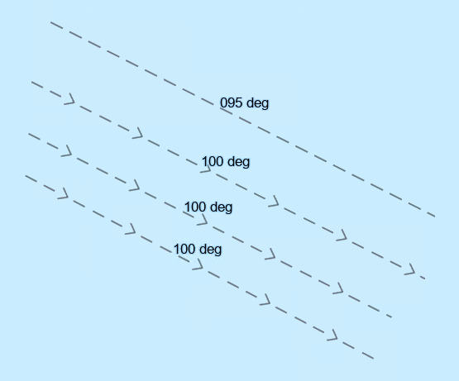
Expected Test Results | 101_1286: An error “orientationValue for RecommendedTrack does not correspond to the bearing of the line.” must be triggered.
Secondary Critical Errors | None

Dataset Name | 10100AA158004 |  | S‐158 Check |  | 101_1205 |  |  | Type |  | C
S-158 Description | For each SweptArea which is not COVERED_BY the combined coverage of DepthArea and DredgedArea features.
Message | SweptArea feature is not covered by a suitable Skin of the Earth feature.
Solution | Ensure SweptArea feature is completely covered by DepthArea or DredgedArea features. |  |  |  | Conformity |  | PS 11.5.1
Test Case No. 1 | SweptArea feature is not covered by a suitable Skin of the Earth feature.
Location | Feature | Attributes |  | FRID |  | FOID |  |  | VRID
32.358184798S, 61.748389344E | SweptArea | depthRangeMinimumValue 200 |  | 18 |  | 1810:6823:1 |  |  | -
Screen Capture | 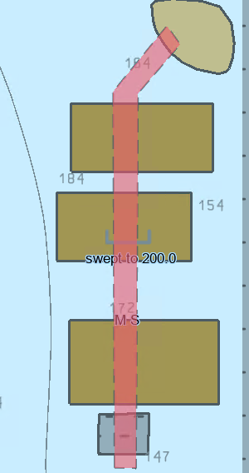
Expected Test Results | 101_1205: An error “SweptArea feature is not covered by a suitable Skin of the Earth feature.” must be triggered.
Secondary Critical Errors | None

